**Employability game – Dairy 1**

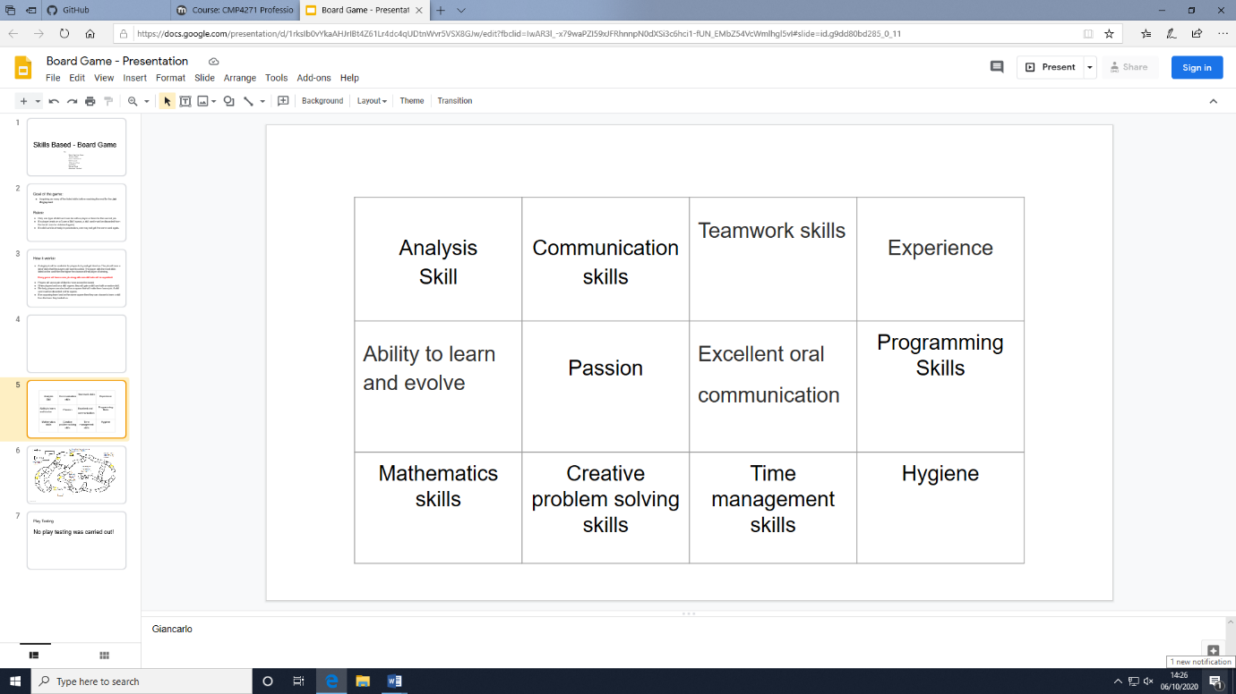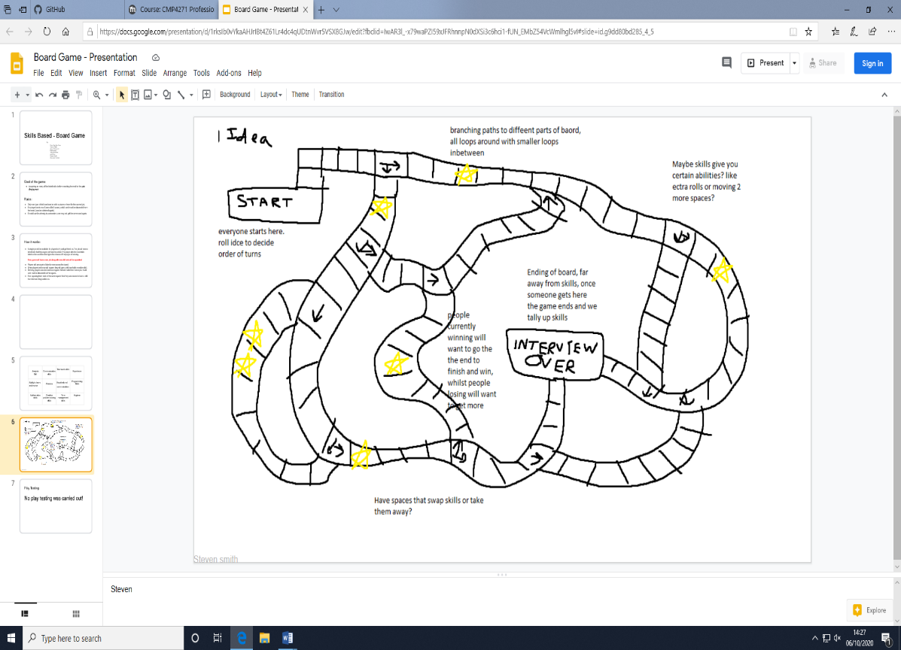The premise of our game was based on the skills that an employer will potentially look for when people are applying to be a games designer. These skills can be gathered throughout the game, individually or as a team, so that the first people employed are the winners. Skills are found on the board and have a correlating skill card to match them for the player. This game is a minimum of 2 players and a maximum of 6. The board game is portable, there are 12 skill cards, one dice and 6 player pieces.

Figure . 12 skills that can be collected.

Figure . A draft of the game board.

At the beginning of the game a new job, with skill specifications, will become available to all players and teams. Players must make their way around the board collecting the right skills as quickly as possible before their opponents. The player with the most skills that are on the specification wins and gets hired. To collect a skill a player must land on a ‘Skill square’ where they will be then given a random skill card, alternatively a skill can be lost by landing on a ‘Lose a Skill’ square. When losing a skill one card must be discarded back in to the pile but can be obtained again later in the game.

If an opposing team lands on a players square then the opposing team can take a skill from that player.

Unfortunately the game was not play tested due to our team running out of time. We found that coming up with a basic concept for a game is harder than initially thought and we took too much time getting to know one another. Play testing the game could of helped us tweak and improve it encase of issues like being unbalanced in one teams favour for example.

Although we may not have being able to play test, investing some time in getting to know the team has its benefits. We were able to come to agreements much quicker and almost had the same flow of ideas between us, which furthered our work as we all had a similar idea in mind.

The main skills that I learnt and think are the most important are ‘Time management’ and ‘Team communication’. Being able to manage the time you are given effectively in a task can be the deciding factor in if a project gets completed or not. If we had communicated more efficiently we could have pushed our work further and completed the task although I felt like we worked well as a team. To improve this we could have used a platform we are all familiar with to talk on as that was our first main issue that could have been fixed faster than it was. We didn’t assign team roles which is something I would also change. Having roles organises a team so that nobody is not sure on what they are doing and having a team leader can also help with making tough decisions if people are aren’t agreeing on something.

Team Members

Steve Yap Hou Yuen

Rowan Noble

Jason Pawlowski

Will Connell

Kelly Jane Strat

Josh Wye

Steven Smith

Giancarlo Trinidad